**Prerequisites:**

The following requires administrator privileges within the Duke University MIDS account.

**Configure IAM Settings**

**Step 1: Create Group Access Policy**

AWS Console > IAM > Policies > Create Policy > JSON Editor > Add Policy:

{

"Version": "2012-10-17",

"Statement": [

{

"Sid": "VisualEditor0",

"Effect": "Allow",

"Action": "lightsail:GetCostEstimate",

"Resource": [

"*"

]

},

{

"Sid": "VisualEditor1",

"Effect": "Allow",

"Action": "lightsail:Get*",

"Resource": [

"*"

]

}

]

}

Policy Name: `lfr-student-access`

Policy Description: `Lightsail for Research Student Access`

**Step 2: Create User Group**

AWS Console > IAM > User Groups > Create Group

Create a user group name with the format: `lfr-{course code}-{semester}` eg. ‘lfr-721-fall24’

Attach permissions policies > search for `lfr-student-access` > Attach policy > Create Group

**Step 3: Enable IAM Users to Change Password**  
  
IAM > Account Settings > Edit Password Policy > Custom

**Configure Budget Controls**

**Step 1: Create Budget**

AWS Console > Billing & Cost Management > Budgets > Create Budget

Set a monthly budget per approved amount by the department

**Configure threshold alerts for 80% actual and 95% forecasted > Review > Create Budget

**Onboard Students**

For each student take the following successive steps

**Step 1: Create Student Instance**

AWS Console > Lightsail for Research > Create Virtual Computer

Region: US East (Ohio) [us-east-2]

Application: Ubuntu

Name virtual computer: `{duke netID}-{machine type}-{size}` eg: kh495-gpu-xl

**Step 2: Add Cost Control**

Lightsail for Research > Cost Control > Create Rule > Select student instance > Apply rule:

**Step 3: Get Instance ARN**

AWS Console > Launch AWS Cloud Shell > Run the command:

$ aws lightsail get-instance --instance-name <student-instance-name>

Copy the student instance ARN for use later

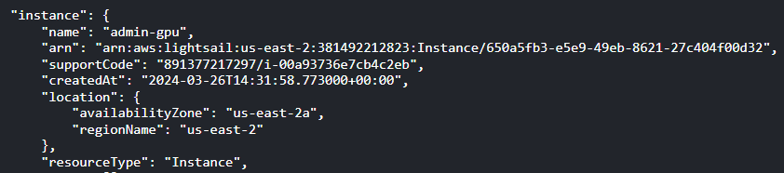

**Step 4: Configure Student IAM**

AWS Console > IAM > Users > Create User

User Name: `{duke netID}`

Add student to course group:

Copy and store student’s unique onetime password for use later > View User

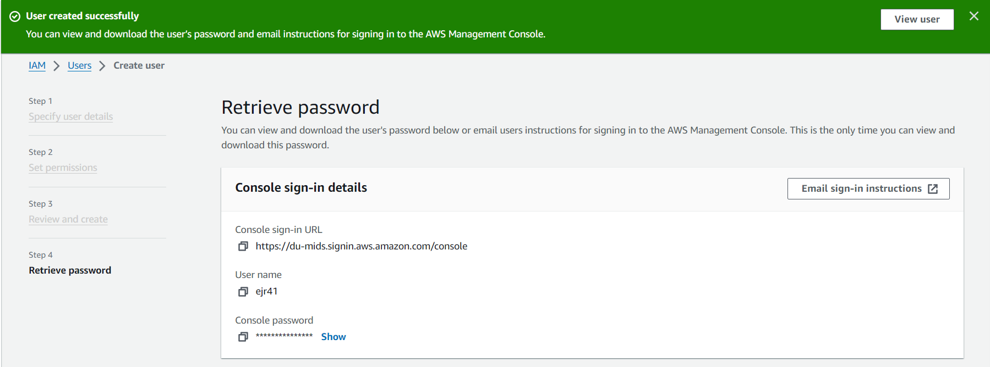

Add Permissions > Create Inline Policy > JSON Editor

{

"Version": "2012-10-17",

"Statement": [

{

"Sid": "VisualEditor1",

"Effect": "Allow",

"Action": "lightsail:*",

"Resource": [

"arn:aws:lightsail:us-east-2:###:Instance/###"

]

}

]

}

Note: Replace `arn:aws:lightsail:us-east-2:###:Instance/###` with the student ARN

Policy name should be of the format: `lfr-{duke netID}-access`

**Step 5: Onboard Student**

Send student the ‘For Students’ docs and their unique onetime password

**Step 6: Forgotten Passwords**

Refer to “[Managing passwords for IAM users](https://docs.aws.amazon.com/IAM/latest/UserGuide/id_credentials_passwords_admin-change-user.html)” to reset passwords for IAM User Roles

**SSH Access**

**Step 1: Retrieve the SSH Key Pair**

AWS Console > Launch AWS CloudShell

$ aws lightsail download-default-key-pair --region *us-east-2* > dkp-details.json

$ cat dkp-details.json | jq -r '.privateKeyBase64' > dkp_rsa

**Step 2: Download dkp_rsa**

**Step 3: Send to student**

Only distribute to students who request SSH access